**[Lab 1] Android Introduction**

Name: Nguyễn Thành Trung – 19522431

Link Github:

Exercise 1:

Exercise 2:

Exercise 3:

Exercise 4:

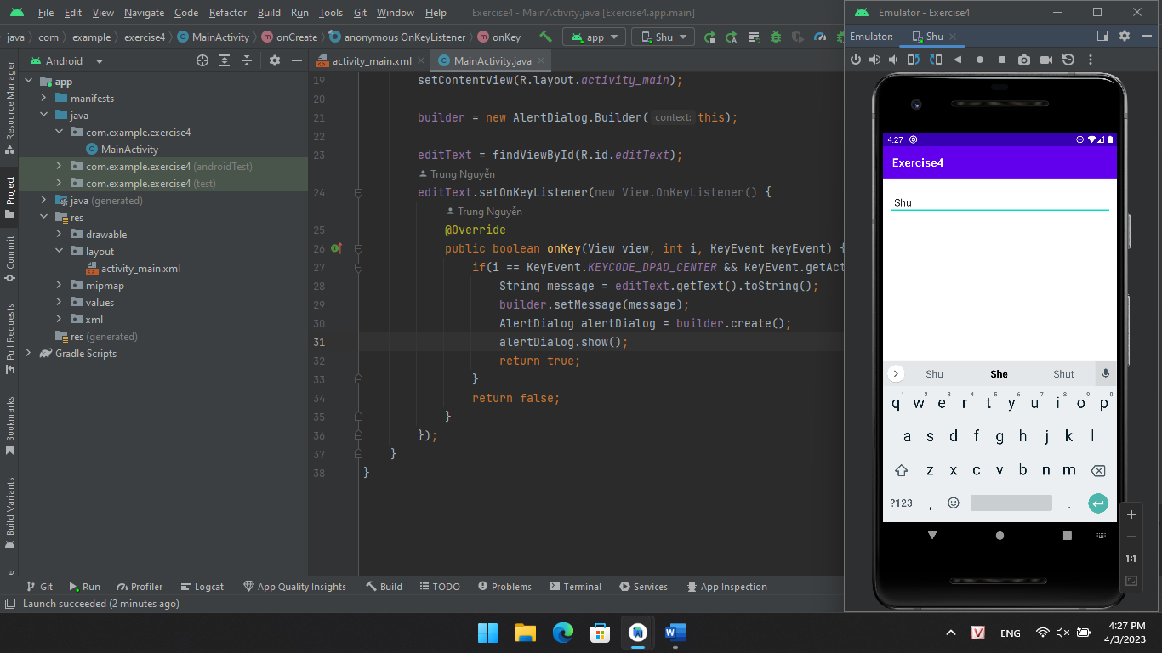

Exercise 5:

